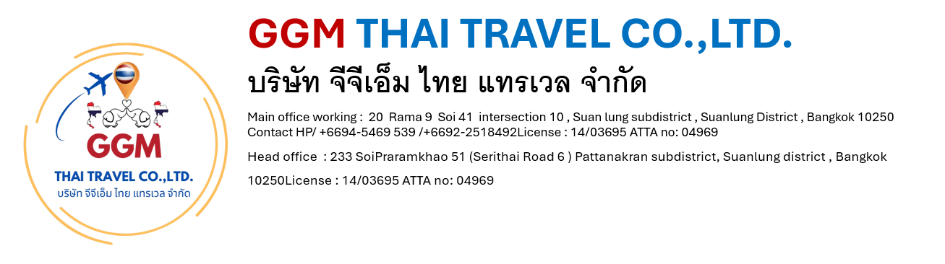

Chiang Mai & Chiang Rai Muslim Tour 4 Days/3 Nights

Tour Highlights: Old City & City Gate / Kantoke Dinner (Halal) / Elephant Safari / Orchid Farm / Chiang Rai / Black House Museum/ Golden Triangle / Chiang Mai Home Industries
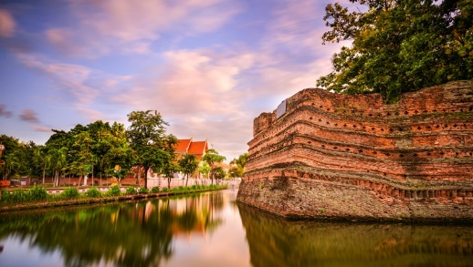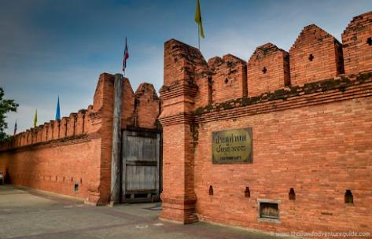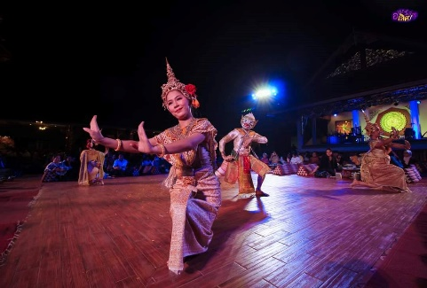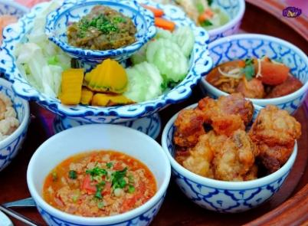

Day 1: Arrival Day - City Tour – Kantoke Dinner (-/-/D)
• Morning / Afternoon - Warmly welcome at Chiang Mai Airport
• City Tour around the old city of Chiang Mai where's surrounded by the ancient wall.
• Visit Tha Pae Gate (The photo landmark)
• 18.00 - 20.30 pm. Have a Kantoke Dinner with a Northern Thai food dinner and Thai tradition dancing performance at Khum Kantoke Restaurant (Halal)
• Transfer to check in at hotel in Chiang Mai town, free and easy.
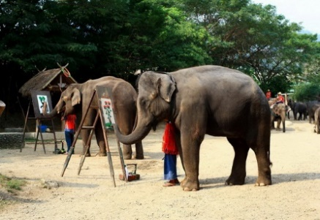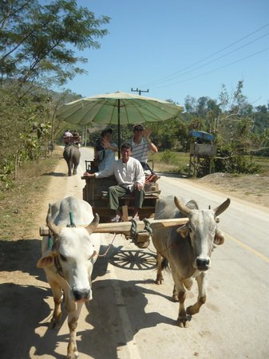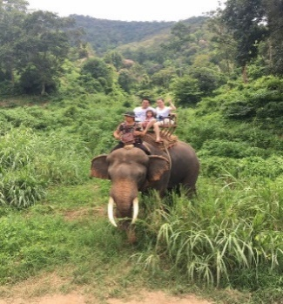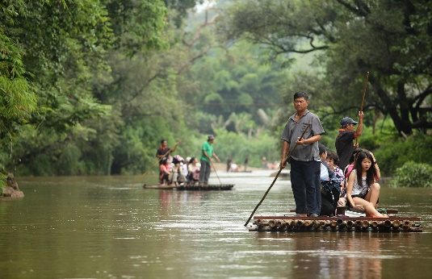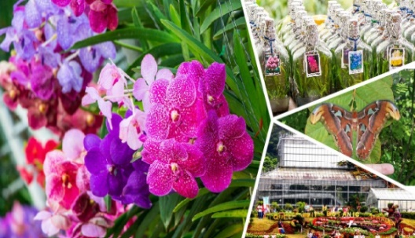

Day 2: One Day Elephant Safari Tour (B/L/D)
• 08.30 am. Pick up at hotel and departure to the north part of Chiang Mai
• 09.45 am. Visit to Mae Tang Elephant Camp
• To see elephant show
• Elephant Riding around 25 - 30 minutes
• Ox-cart riding around 20 minutes
• 12.00 pm. Buffet lunch at elephant camp (Halal)
• Enjoy with the bamboo rafting along Mae Tang stream
• Visit Orchid & Butterfly Farm
• 17.30 pm. have a dinner at local Halal restaurant
• 19.00 pm. Transfer to hotel, free and easy.
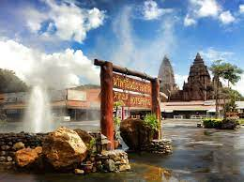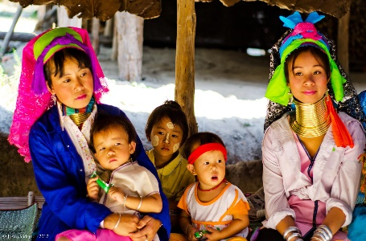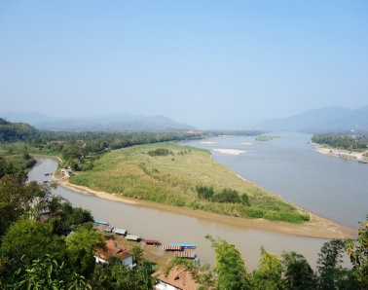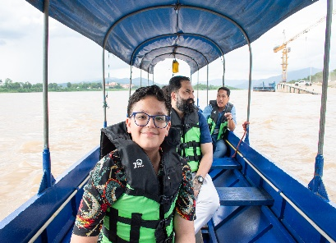
Day 3: One Day Chiang Rai Tour (B/L/D)
• 07.30 am. Pick up at hotel and departure to Chiang Rai around 3 – 3. hours
• Take a short break at Mae Kajarn Hotspring
• Visit Karen Long Neck & Hilltribes Village
• 12.30 pm. Lunch at local Halal restaurant
• Continue to Golden Triangle to see the 3 borders meeting view point (Laos, Myanmar and Thailand)
• Boat trip along Mae Khong river and visit Laos Border Market
• Driving back to Chiang Mai and have a dinner at local Halal restaurant
• 21.30 pm. Transfers to hotel
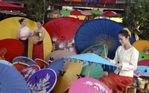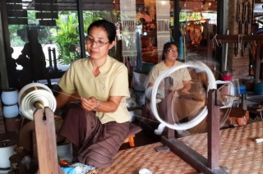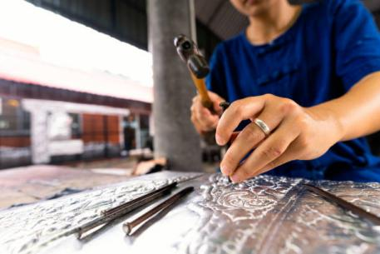
Day 4 : Home Industries - Departure Day (B/L/-)
• 09.00 am. Pick up at hotel.
• Visit San Kampeang Handicraft Village is well known of hand made product such as umbrella making, silver ware, lacquer ware, Thai silk, gems stone and wood carving.
• 12.00 pm. Lunch at local restaurant
• Afternoon – Transfers to Chiang Mai Airport (Depends on the flight.)

